PROBLEM STATEMENT

**Ideated by (Name):** Priya Mahanty and Swami Pragya Prashant

**Subject:** Biology

**Title (Concept/Chapter/Question):** Game of Life

**Simulation tailored to:** Teach the working principles and concepts of different life processes within the human body with a visual understanding of the respective organ systems.

**Type:** Adaptive

**Description:** The simulation aims to teach the students the concept of different Life Processes in humans by making them well acquainted with the different parts of the respective systems, their assembly as an organ system and working. Students must identify the respective organs from a reel of organs and then arrange them in the right order and test its functionality. A successful identification and assembly of the organs will result in a successful simulation. In the case of a failed simulation, the student(s) shall be asked to go through the theory once again and find out what they are missing.

**Template:** 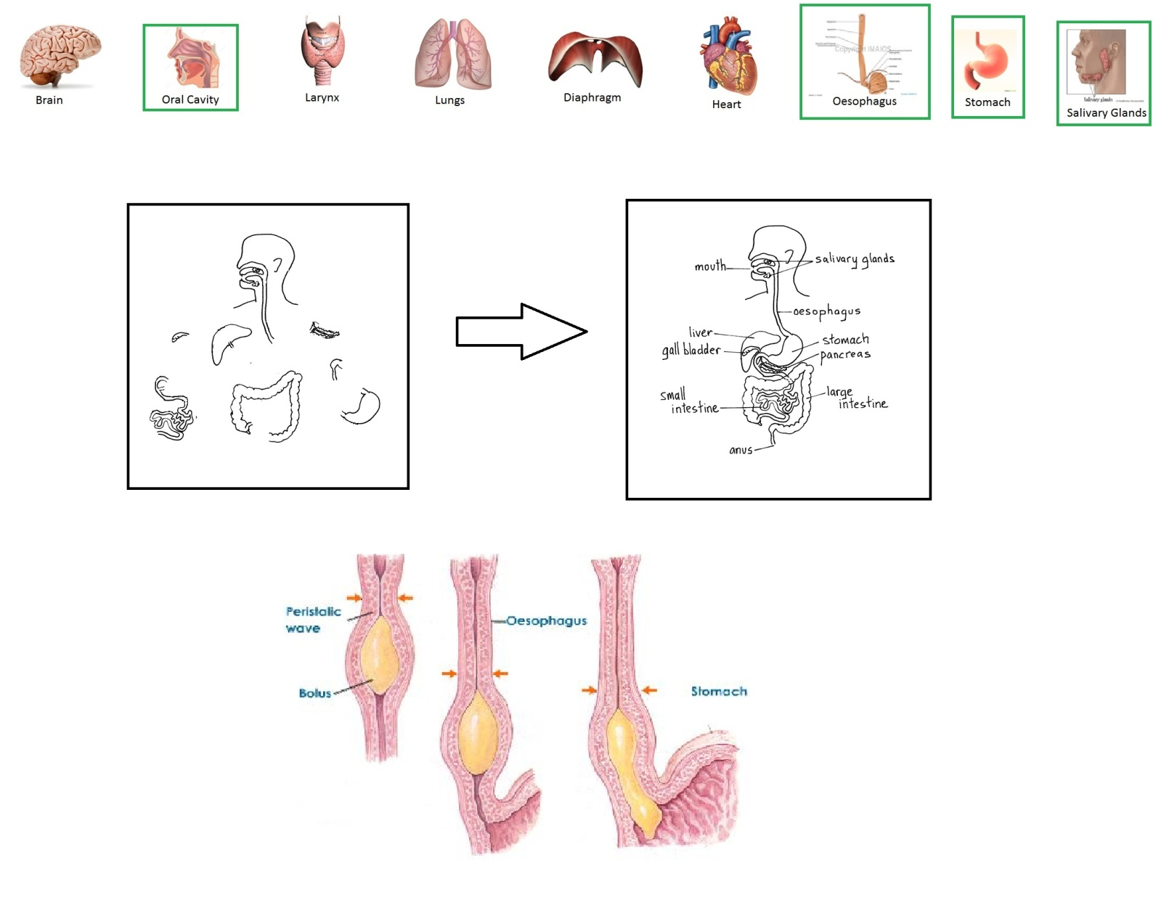

The students will select the organs required in the system from a moving reel of different body organs. Once the organs have been selected, they will be transferred to another box where they need to be arranged as in the system like a jigsaw puzzle. Depending on the grade of student, there will be different difficulty levels. For example, in the case of digestive system, for a Class 7 student, only identification and assembly is enough. The food shall pass automatically through the system and be digested. For a class 10 student, the food will have to be passed manually along with addition of enzymes and digestive juices by the student at each respective organ. If the student gets all the organs identified and assembled correctly, phase I of the simulation will be completed. In Phase II, the student shall add the enzymes and make the food digest. If the proper enzymes will be added at every step, the food will be digested and the simulation will be completed successfully.

**Test cases:**

**Organs moving on the reel**: Cerebrum, Thalamus, Hypothalamus, Mid Brain, Pons, Medulla Oblongata, Cerebellum, Pituitary Gland, Spinal Cord, Cell Body, Dendrons & Dendrite, Axon, Myelin Sheath, Nerve Ending, neuro-muscular junction, Right Atrium, Right Ventricle, Left Atrium, Left Ventricle, Vena cava, Pulmonary artery, Pulmonary vein, Aorta, Blood capillaries, Glomerulus, Bowman's Capsule, Proximal Tubule, Loop of Henle, Distal Tubule, Collecting Duct, Renal Artery, Renal Vein, Kidneys, Ureter, Urinary Bladder, Urethra, Teeth, Tongue, Oral Cavity, Slaivary Glands, Pharynx-Epiglottis-Oesophagus, Stomach, Pancreas, Liver (with bile duct), Gall bladder (with bile duct), Small Intestine, Large Intestine, Appendix, Rectum and Anus, Ovary, Fallopian Tube, Uterus, Cervix, Vagina, Prostate Gland, Seminal Vesicle, Vas deferens, Testis + Scrotum, Penis, Nasal Cavity, Pharynx-Epiglottis-larynx, Trachea, Right and Left Bronchus, Bronchioles, Alveoli and capillaries, Pineal gland, Thyroid gland, Parathyroid gland, Thymus-gland, Adrenal gland.

1. **Nutrition   
   Organs of the Human digestive system in order of their appearance and positioning:-**1. Oral cavity,   
   2. Salivary glands,  
   3. Pharynx-epiglottis-oesophagus,   
   4. Stomach,   
   5. {(liver, pancreas, gall bladder) – accessory organs},   
   6. Small intestine,   
   7. Large intestine,   
   8. Rectum and Anus.

The food passes through the digestive system in the same order as mentioned above. Any discrepancy in the ordering of the organs shall result in a failed simulation.

1. **Central Nervous System  
   Organs of the Central Nervous System:-**1. Fore Brain (Cerebrum, Thalamus, Hypothalamus)   
   2. Mid Brain  
   3. Hind Brain (Pons, Medulla Oblongata, Cerebellum)  
   4. Pituitary Gland.  
   5. Spinal Cord.  
   6. Neuron (Cell Body, Dendrons & Dendrite, Axon, Myelin Sheath, Nerve Ending)  
   7. Neuro-muscular junction.  
     
   The neuron is the fundamental unit of the central nervous system. The simulation will begin with assembly of neuron from its parts. A proper assembly of neuron will result in a nervous tissue from which brain and spinal cord will also be formed. Finally, the CNS assembly needs to be attached to the muscles via neuro-muscular junctions. Upon joining, the CNS takes control of the living body for its activities.
2. **Respiratory System  
   Organs of the Respiratory System:-**1. Nasal Cavity  
   2. Pharynx-Epiglottis-larynx  
   3. Trachea.  
   4. Right and Left Bronchus  
   5. Bronchioles  
   6. Alveoli and capillaries.  
     
   The respiratory system simulation will aim to teach the students the mechanical process of breathing – inhalation, exchange of gases, and exhalation. The absorbed oxygen is then passed on to the heart via pulmonary vein and circulated to the other parts of the body.
3. **Circulatory System  
   Organs of the Circulatory System:-**(1. Right Atrium  
   2. Right Ventricle  
   3. Left Atrium  
   4. Left Ventricle) = Heart  
   5. Vena cava  
   6. Pulmonary artery  
   7. Pulmonary vein  
   8. Aorta  
   9. Blood capillaries.  
     
   The circulatory system functions with blood as its major connective tissue. It’s used for transportation of oxygen, antibodies, endocrine secretions, and body temperature regulation.
4. **Excretory System  
   Organs of the Excretory System:**-  
   {1. Glomerulus  
   2. Bowman's Capsule  
   3. Proximal Tubule  
   4. Loop of Henle  
   5. Distal Tubule  
   6. Collecting Duct  
   } = Nephron  
   7. Renal Artery  
   8. Renal Vein  
   9. Kidneys  
   10. Ureter  
   11. Urinary Bladder  
   12. Urethra.  
     
   The excretory system functions to remove the nitrogenous waste generated as the by –product of the cellular reactions. Its basic unit is known as ‘nephron’. Assembly of a nephron will lead to formation of kidney; fitting the kidney with the accessory organs will enable the system to filter out nitrogenous waste from the blood and reject it as urine.
5. **Reproductive System  
   Organs of the Reproductive System:-  
   1. Female:** 1. Ovary 2. Fallopian Tube 3. Uterus 4. Cervix 5. Vagina (Post fertilization – 6. Placenta, 7. Umbilical cord, 8. Amniotic sac and fluid)  
   **2. Male:** 1. Ureter 2. Urinary Bladder 3. Urethra 4. Prostate Gland 5. Seminal Vesicle 6. Vas deferens 7. Testis + Scrotum 8. Penis  
     
   The reproductive system simulation shall focus on release of the gametes and their fertilization and development of the zygote. Upon fertilization of the egg by the sperm, the female reproductive system will develop the organs which are needed in the incubation period before the birth of the child.
6. **Endocrine System  
   Endocrine Glands:**-  
   1. Pineal Gland  
   2. Pituitary gland  
   3. Hypothalamus  
   4. Thyroid gland  
   5. Parathyroid gland  
   6.Thymus  
   7. Adrenal gland  
   8. Ovaries (in females)  
   9. Testes (in males)  
   10. Pancreas.  
     
   The Endocrine system releases hormones directly into the blood stream and controls many different functions of the body.

**References:** Class 10 NCERT Science Book, CH – Life Processes, Control & Coordination, Reproduction.

**Review Comments**: